# AI Powered Innovation

## Garage Growth Framework + AI

### Jim Kelly, Director Microsoft Garage Ireland

# Workshop Outline

## Microsoft Garage

## AI-powered Innovation

## Learnings to date.

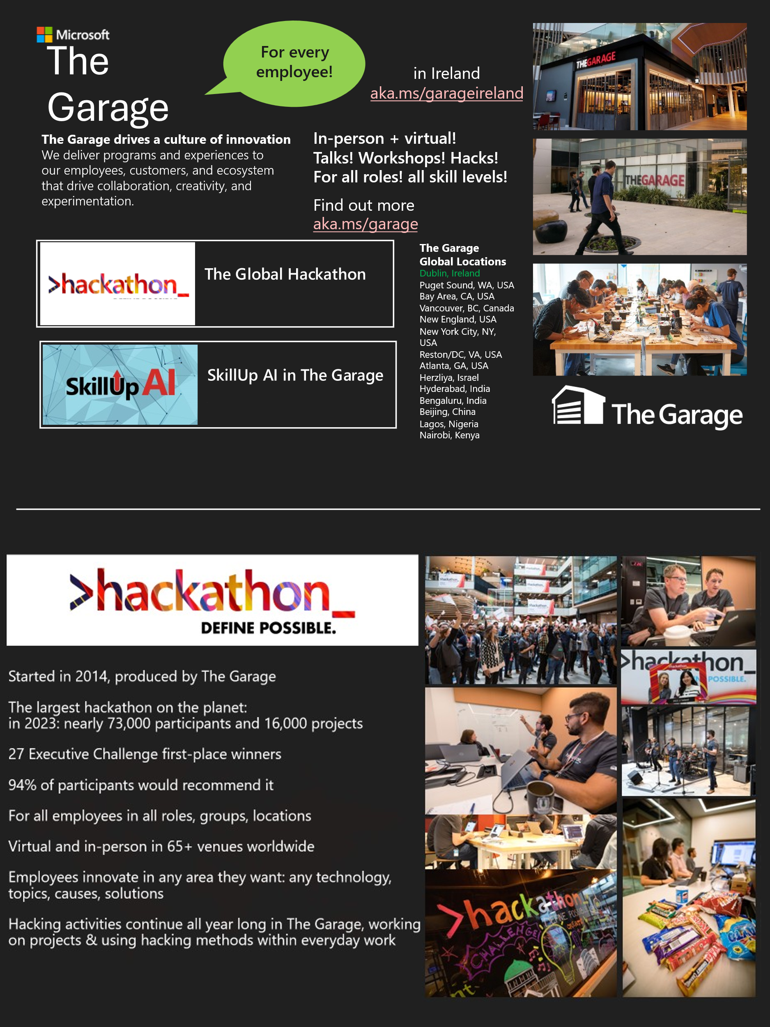

# AI Powered Innovation Overview:

## Inspiration: take an AI-first approach to innovating.

## An immersive, fast-paced, hands-on, co-innovation workshop, that will give you a taste of how the Microsoft Garage enables innovation with AI.

# Gartner AI Opportunity Radar:

## The Garage Growth Framework

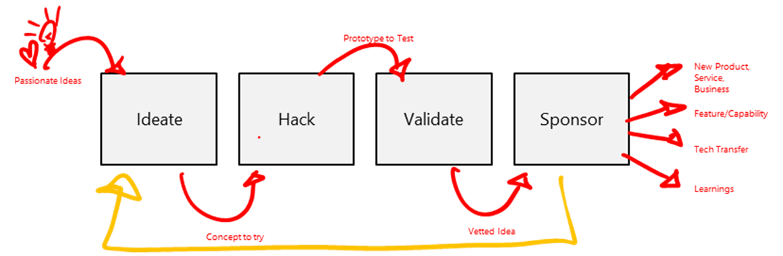

# X

# AI (Copilot Prompts)

# Getting the most out of the workshop:

## Open mind: embrace this as a hands-on exploration – experience the potential of AI as your co-innovation assistant.

## Build understanding.

## Have fun - enjoy the process.

## Be a “learn-it-all” - connect and knowledge share.

## Patience: early stages, there will be bumps.

# Before we get started…

## Save and rename a copy of the workbook for you to edit

## Open Copilot Enterprise version (Biz Chat) <https://m365.cloud.microsoft/chat>

## Login with your work credentials

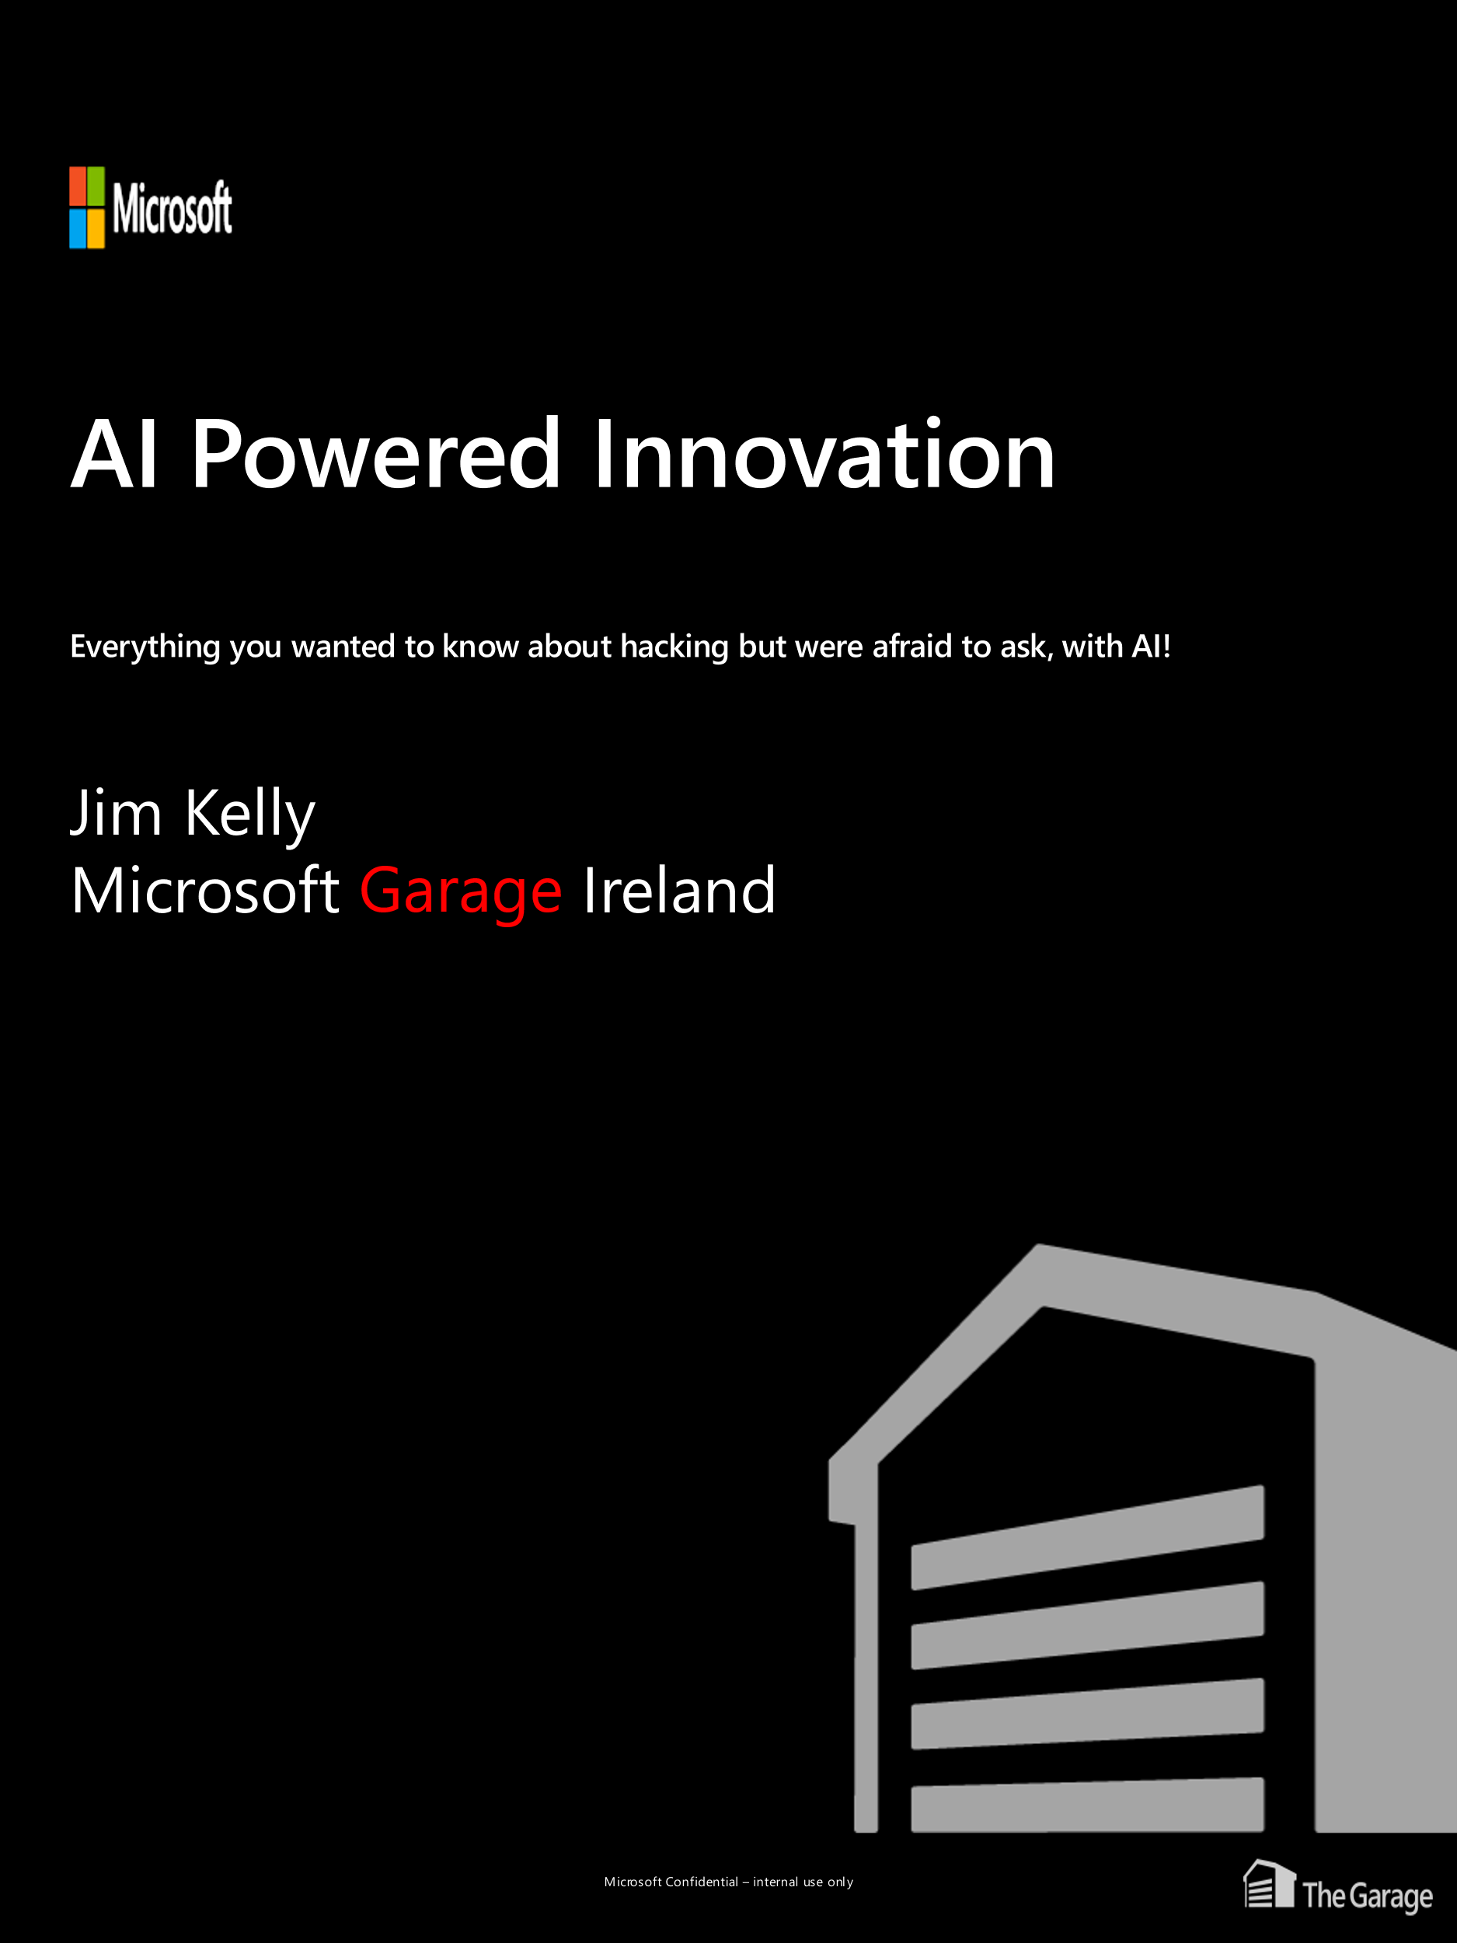

Search Mindset

Prompt:

Give me an itinerary for a fabulous weekend for a couple in Paris.

PROMPT IS NOT SEARCH

Prompt Mindset

Prompt:

Taking that weekend planning example here’s how you might structure and better prompt yielding better results (walk through the below)​

**[Persona]**​ Act as if you are the world’s best local tour guide for Paris.

**[Objective]​** Design for me a 3-day itinerary for a wonderful experience.

**[Audience]​** We are a couple who’ve been to Paris many times before and have visited all the top sights. We’re looking to experience the true local Paris and hidden gems.

**[Output Parameters]**​ Summarise the output in a table by day and segment each day by morning, afternoon, evening and nighttime. Include public transport options for each recommendation.

**[Context]**​ We are avid walkers and would love recommendations for walks and hikes in Paris. We love visiting quirky museums and sights. Please include recommendations for authentic, affordable food and drink experiences for breakfast, coffee, lunch, aperitifs, dinner and evening drinks.

----------------------------------------------------------------------------------------

Act as if you are the world’s best local tour guide for Paris.

Design for me a 3-day itinerary for a wonderful experience.

We are a couple who’ve been to Paris many times before and have visited all the top sights. We’re looking to experience the true local Paris and hidden gems.

Summarise the output in a table by day and segment each day by morning, afternoon, evening and nighttime. Include a column outlining public transport options for each recommendation.

We are avid walkers and would love recommendations for walks and hikes in Paris. We love visiting quirky museums and sights. Please include recommendations for authentic, affordable food and drink experiences for breakfast, coffee, lunch, aperitifs, dinner and evening drinks.

Setting up Copilot

as our

AI-powered

innovation assistant

# Setting up Copilot to be our innovation assistant

Prompt:

Act as if you are the best strategic business innovation practitioner and coach in the world. I want you to be my innovation coach and assistant. Your responses should be creative, push the boundaries, challenge the status quo, and seek to reimagine existing products and services.

The team you are coaching are the leaders in the global space industry.

I will provide the opportunity we wish to tackle, so do not ask clarifying questions or suggest possible next steps.

For all responses in this conversation, please provide the information along with the sources you used for your response. Include hyperlinks and references to the sources.

**Steps**

1. Understand the opportunity provided.
2. Generate novel, creative and innovative ideas.
3. Challenge existing norms and propose alternative, groundbreaking solutions.
4. Provide detailed explanations and reasoning for each idea.
5. Include sources and references for all information provided.

**Output Format**

Responses should be in a conversational tone, with clear and concise explanations. Include citations, hyperlinks and references to all sources.

Let’s

Get

Started!

Focus on a **BIG** opportunity, something *you* are passionate about.

Your Opportunity Statement:

How might we …?

# Enhance draft Opportunity Statement

Prompt:

I want you to enhance and refine the opportunity statement below using the following framing and criteria:

An opportunity statement requires a clear, visionary, and actionable directive. An effective statement should ignite passion, drive focus, and communicate a future-oriented vision.

The attributes of a good opportunity statement are:

* **Visionary**: The statement should paint a compelling picture of the future and describe what success looks like. It should challenge the status quo and inspire a bold new direction.
* **Customer-Centric**: It must emphasize creating value for the customer, understanding their needs, and how the transformation will enhance their experience.
* **Outcome-Focused**: Instead of merely describing actions (like "implement AI"), it should describe desired outcomes ("become the industry benchmark for AI-driven personalized experiences").
* **Measurable**: While it's aspirational, it should hint at something that can be tracked and measured. This allows the team to understand progress and adjust strategies as needed.
* **Urgency**: Especially in a rapidly changing digital environment, the statement should create a sense of urgency, emphasizing the importance of acting now.

Think this through step by step: generate an excellent Opportunity Statement inspired by the draft Opportunity Statement below in the “How might we …?” format.

**Steps**

1. Review and understand the draft opportunity statement
2. List an additional 5 differentiated possible opportunity statements.
3. Critique the list, summarise the critique and add three more.
4. Create a table of all opportunity statements, including the draft, listing detailed strengths and weaknesses of each.
5. Pick the best and explain why it is the best.

**Output Format**

For the original draft and each additional opportunity statement generate an Opportunity Statement that is expert-level, detailed, ambitious, and forward-looking, providing a clear vision for innovation and growth.

* Structure and Format:
  + Title:
    - Purpose: Clearly state the focus of the opportunity.
    - Format: Concise and impactful
  + Executive Summary:
    - Purpose: Provide a brief overview of the opportunity.
    - Format: 2-3 sentences summarizing the key points.
  + Opportunity Description:
    - Purpose: Define the specific opportunity for innovation.
    - Format:
      * Opportunity Statement: Clearly articulate the opportunity or desired gain.
      * Ambition and Vision: Highlight the ambitious nature and forward-looking aspects of the solution.

**Draft Opportunity Statement:**

Paste here … Capture energy from solar flares to use as energy on earth or satelites or space craft  
Persona is: advanced systems engineer at nasa

**Ideate**

Hack

Validate

Sponsor

The Garage Growth Framework



New Product, Service, Business

Feature/Capability

Tech Transfer

Learnings

Vetted Idea

Prototype to Test

Concept to try

Passionate Ideas

Generate

Ideas.

# Leveraging Copilot to generate ideas.

Prompt:

**Generate 10 Radical, Non-Obvious Ideas**

**Objective:** Innovate by generating genuinely new, novel, wild, and radical ideas to tackle the final opportunity statement below on behalf of the persona.

**Guidelines:**

1. **Challenge the Status Quo:** The ideas should disrupt the market and challenge existing norms.
2. **Excite and Energise:** The ideas should be ambitious, written from an abundance perspective, and have huge potential.
3. **Brevity:** Keep the ideas brief and to the point.
4. **Highlight Disruption:** Clearly indicate how each idea disrupts the current status quo.
5. **Feasibility:** Ensure that the ideas are technically feasible within the next 5 years.
6. **Customer-Centric:** Focus on the customer and how the ideas will benefit them.

**Steps:**

1. **Understand the Customer:** Consider the needs, pain points, and desired gains of the customer with respect to the Opportunity Statement, for whom you are generating ideas for.
2. **Generate Wild, Radical, Non-Obvious Ideas:** Think beyond conventional solutions and explore wild, radical possibilities.

**Output Format:**

* List 10 radical, non-obvious ideas.
* Each idea should be brief, to the point, and clearly indicate how it disrupts the current status quo.
* Include a brief explanation of the feasibility and customer-centric benefits of each idea.

**Final Opportunity Statement:**

How might we transform solar superstorms from existential threats into the foundation of a new space-powered economy — by harvesting their excess energy to power autonomous orbital stations, beam clean electricity to Earth, and establish a resilient, intelligent interplanetary energy grid?

# Leveraging Copilot to rate and rank ideas.

Prompt:

**Rate and Rank All the Ideas**

**Objective:** Critically, expertly and objectively review and analyse the generated ideas. Rate and rank them according to the criteria below with precision and accuracy.

**Guidelines:**

1. **Desirability:** Does the idea show a deep understanding of customer’s pain points, desired gains, and limitations?
2. **Opportunity Relevance:** Does the idea address the specific opportunity statement for career.io?
3. **Innovation Level:** Is the idea new and creative, or is it a replication of existing solutions?
4. **Feasibility:** Can the product or service be built? Can the idea be quickly turned into a prototype for testing?
5. **Market Opportunity:** Is there a market for this idea? What is the estimated Total Addressable Market (TAM) and are there potential customers willing to pay for this idea?
6. **Impact:** What is the potential business value of the idea on the market and the customer’s pain points and desired gains?

**Instructions:**

1. **Critically and objectively apply the Criteria:** Apply the criteria to each all the ideas.
2. **Score Each Idea:** Score each idea on each criterion on a scale of 0 to 5, where 0 is the lowest and 5 is the highest. Ensure differentiation between each idea for each criterion.
3. **Justify Scores:** Provide a brief justification for each score to ensure a thorough evaluation.
4. **Rank the Ideas:** Rank the ideas in a table based on their total scores.

**Output Format:**

* Provide a table with the ideas ranked based on their total scores.
* Include the scores for each criterion and a brief justification for each score.
* Ensure the table is clear and easy to read.

Ideate

**Hack**

Validate

Sponsor

The Garage Growth Framework



New Product, Service, Business

Feature/Capability

Tech Transfer

Learnings

Vetted Idea

Prototype to Test

Concept to try

Passionate Ideas

Hack together something to test out the idea.

# Create a Storyboard – a universal Prototype

Prompt:

**Storyboard for the final Idea below**

**Objective:** To help understand the idea, and how it would work in reality, tell the story for the idea in the form of a storyboard.  
  
The customer/user: the customer / user

**Guidelines:**

1. **Specificity:** The storyboard should be specific to the idea.
2. **Expert Level:** Ensure the storyboard is at an expert level with at least three bullet points per cell.
3. **Demo Video:** The storyboard should be designed to help create a demo video.
4. **Voice-Over:** Include a voice-over for each panel.

**Instructions:**

1. **Generate Storyboard:** Generate a 6-scene storyboard to explain how the idea will transform for the better the customer’s situation.
2. **Panel Details:** Each scene should have a detailed scene description and voice-over.
3. **Table Format:** Represent the storyboard in a table with the following columns: Scene Number, Scene Description, Voice Over.

**Steps:**

1. **Identify Key Moments:** Identify the key moments that illustrate how the idea transforms the customer’s situation.
2. **Describe Scenes:** Describe each scene in detail, focusing on the visual elements and actions.
3. **Write Voice-Over:** Write a voice-over script for each scene that complements the scene description.
4. **Organise in a Table:** Organise the storyboard as a table in a file with the specified columns.

**Output Format:**

* Provide a table with 6 scenes.
* Each scene should include a detailed scene description and a voice-over script.
* Ensure the table is clear and easy to read.

Final idea:  
Paste here

**Solar Storm Catcher Swarms:**

This initiative proposes the development of **AI-driven, autonomous swarms of energy-harvesting satellites** that dynamically reposition during solar superstorms to capture peak electromagnetic and particle radiation. Unlike static systems, these swarms act as intelligent, adaptive collectors — converting solar volatility into a **distributed energy network** that powers orbital stations, lunar infrastructure, and eventually beams energy to Earth.

By harnessing the **most extreme bursts of solar power**, these swarms serve as the foundation of a **new space energy economy**, enabling scalable, resilient, and monetisable power in orbit.

# Create Storyboard Images

Prompt:

**Create an image of a storyboard sketch in the style of a pencil drawing for scene 1.**

**Detailed Instructions**

1. Scene Description: Provide a detailed depiction of scene 1. Include elements such as characters, setting, actions, and any specific objects or features that should be included in the sketch.
2. Voice-over Narrative: include inspiration from the voice-over narrative that accompanies the scene. This will help in understanding the context and emotions that need to be conveyed through the sketch.
3. Style: Ensure the sketch is in the style of a pencil drawing, capturing the essence of traditional storyboard sketches. Focus on, line work, shading, and texture to create a realistic and engaging image.

**Output Format**

The output should be a single image that accurately represents the scene description and voice-over narrative. The image should be in high resolution and suitable for use in a storyboard presentation.

# Create a prototype Value Proposition Canvas

Prompt:

**Role/Context:**  
For this task you are a seasoned business strategist and consultant with deep expertise in product-market fit, customer profiling, and value proposition design. For the **top ranked idea** we need to construct a **Value Proposition Canvas** at an expert level. The canvas should clearly map how the **company** (as the provider) delivers value to the **customer** (as the customer profile).

The Company is: company

The Customer / User is: Customer / User

**Key Instructions:**

1. **Overall Structure**
   * Present the Value Proposition Canvas in a **classic two-sided table** format:
     + **Left Side: Customer Profile (Customer)**
       - **Customer Jobs**
       - **Pain Points**
       - **Desired Gains**
     + **Right Side: Value Map (Company)**
       - **Products & Services**
       - **Pain Relievers**
       - **Gain Creators**
   * For each section, provide **detailed, expert-level** descriptions, bullet points, or short paragraphs.
2. **Depth and Clarity**
   * Thoroughly explain each element:
     + **Products & Services:** Summarize the core offerings relevant to the idea.
     + **Pain Relievers:** Show how these offerings alleviate the customer’s pain points in a granular, solutions-focused way.
     + **Gain Creators:** Demonstrate how they produce tangible or intangible benefits—consider financial, emotional, or strategic gains.
     + **Customer Jobs:** Highlight the key tasks, goals, and problems the customer needs to address in their day-to-day or strategic context with respect to the final opportunity statement.
     + **Pain Points:** Detail the most pressing challenges, obstacles, or risks the customer face with respect to the final opportunity statement.
     + **Desired Gains:** Discuss the outcomes, aspirations, and positive results the customer desires with respect to the final opportunity statement.
3. **Professional Tone & Format**
   * Write in **complete, concise sentences** that convey an **executive-level, professional** perspective.
   * Ensure each table cell is **information-rich** with **practical insights**, implications, and examples or use cases where appropriate.
   * **Use headings and bullet points** (where relevant) within each cell for clarity.
4. **Customization & Examples**
   * Incorporate **industry insights**, **target market nuances**, or **competitive advantages** specific to the idea.
   * Reference **specific features**, functions, or components that differentiate the offering.
5. **Final Output Requirements**
   * Provide the **Value Proposition Canvas** in **a table format**, ensuring it neatly aligns the Value Map and Customer Profile side by side.
   * Make sure each column and row are clearly labelled, and the content is easy to read.

**Prompt to the Model:**

Please create a comprehensive, expert-level Value Proposition Canvas for the idea, in a classic two-sided table format. Format the table as follows: The left side (Customer Profile) should detail the Customer Jobs, Pain Points, and Desired Gains. Include extensive detail and professional insight in each cell**.** The right side (Value Map) should detail the company’s Products & Services, Pain Relievers, and Gain Creators.

**Example of the Table Layout (simplified)**

| **Customer Profile** | **Value Map** |
| --- | --- |
| **Customer Jobs** | **Products & Services** |
| - List the tasks, problems, or needs the customer is trying to address. | - Describe the products and services the company offers to help the customer get their jobs done. |
| **Pain Points** | **Pain Relievers** |
| - Identify the negative experiences, emotions, or risks the customer faces while trying to get their jobs done. | - Explain how the company's products and services alleviate these pains. |
| **Desired Gains** | **Gain Creators** |
| - Highlight the benefits, positive outcomes, or aspirations the customer wants to achieve. | - Detail how the company's products and services create these gains for the customer. |

Replace the bullets and placeholders with **in-depth, context-specific insights** for your final result.

# Create a prototype Business Model Canvas

Prompt:

**Role/Context:**  
For this task you are a seasoned business strategist and consultant with deep expertise in designing, analysing, and refining business models. We have identified top ranked **idea** and now need to construct a **Business Model Canvas** at an expert level. The canvas should depict how the **company** (provider) delivers value to the **customer** (buyer/user).

The Company is: Company

The Customer / User is: Customer / User

**Key Instructions:**

1. **Overall Structure**
   * Present a **Business Model Canvas** in a **table format** covering the **9 standard building blocks**:
     1. **Customer Segments**
     2. **Value Proposition**
     3. **Channels**
     4. **Customer Relationships**
     5. **Key Resources**
     6. **Key Activities**
     7. **Key Partners**
     8. **Cost Structure**
     9. **Revenue Streams**
2. **Depth and Clarity**
   * For each building block, provide **detailed, expert-level** descriptions and insights, such as:
     1. **Customer Segments:** Types or groups of customers targeted; may include different demographic or behavioural segments.
     2. **Value Proposition:** Specific offerings that meet customer needs or solve problems; highlight any unique differentiators.
     3. **Channels:** Distribution, communication, and sales channels used to reach customers effectively.
     4. **Customer Relationships:** Methods to acquire, retain, and grow your customer base.
     5. **Key Resources:** Required assets (physical, financial, intellectual, or human).
     6. **Key Activities:** Critical tasks or operations needed to implement.
     7. **Key Partners:** Strategic alliances, suppliers, complementary businesses, etc.
     8. **Cost Structure:** Main cost drivers, both fixed and variable; link to resources and activities.
     9. **Revenue Streams:** How the company generates revenue (pricing models, subscription, transactional, etc.).
3. **Professional Tone & Format**
   * Write in **complete, concise sentences** with an **executive-level, professional** perspective.
   * Ensure each table cell is **information-rich** with **practical insights** and, if helpful, **examples** or **use cases**.
   * Use **headings or bullet points** (where relevant) within each cell to maintain clarity.
4. **Customization & Examples**
   * Integrate any **industry-specific details**, **best practices**, or **case examples**.
   * Consider **competitive advantages**, **market conditions**, or **technological enablers** that reinforce the business model.
5. **Final Output Requirements**
   * Provide the **Business Model Canvas** in **a table format**, ensuring each of the 9 building blocks has its own row, in the sequence outlined.
   * Make the table easy to read, with columns labelled clearly.

**Prompt to the Model:**

Please create a comprehensive, expert-level Business Model Canvas for the idea in a table format. Provide extensive detail and professional insight for each of the 9 building blocks.

Ideate

Hack

**Validate**

Sponsor

The Garage Growth Framework



New Product, Service, Business

Feature/Capability

Tech Transfer

Learnings

Vetted Idea

Prototype to Test

Concept to try

Passionate Ideas

Test out the idea

# Create a discovery interview script to test the idea

Prompt:

Create a specific discovery interview script to test the final idea with customer / user at an expert level.

1) test and validate the opportunity statement

2) test and validate the solution concept

The discovery interview script should at least include the following sections:

* Introduction
* Understand the Customer’s current situation
* Digging into the pain points and desired gains of the customer
* Understanding existing solutions strengths and weaknesses from the customer’s perspective
* Share the solution concept and value proposition
* Gather feedback and reaction
* Wrap-up, thank you and next steps

Include at least three sentences per section.

**Output Format**

The script should be structured in a table with the following columns: Section, Questions, Purpose.

# Simulate the persona response

Prompt:

Simulate the response of a very sceptical customer / user to the discovery interview for the final idea and storyboard prototype using the discovery interview script.

**Output Format**

The script should be structured in a table with the following columns: Section, Questions, Response, Response Sentiment Analysis, Possible Interviewer Response

Ideate

Hack

Validate

**Sponsor**

The Garage Growth Framework



New Product, Service, Business

Feature/Capability

Tech Transfer

Learnings

Vetted Idea

Prototype to Test

Concept to try

Passionate Ideas

Secure a sponsor

# Generate an outline for a sponsor pitch deck

Prompt:

Create a specific PowerPoint pitch deck outline at the expert level to pitch and secure support from the Board of Investors to invest and proceed with implementation of the final idea.

**Detailed Instructions**

Be specific and detailed to the idea and incorporate relevant facts and market data. Source reference data, provide citations and hyperlinks to sources. Use bullet points for key information. Format as a text document with a section for each slide title and the key bullet points explaining each slide. Number each slide.

**Slide 1: Introduction**

* **Title**: [Insert compelling Introduction]
* **Key Bullet Points**:
  + Mission statement: [Insert mission statement specific to the idea]
  + Brief overview of the idea: [Provide a detailed description of what the idea does]
  + Importance of the idea: [Explain why the idea is important and relevant]

**Slide 2: Problem**

* **Title**: Problem
* **Key Bullet Points**:
  + Outline the problem: [Describe the problem that the idea aims to solve]
  + Establish the need: [Explain why this problem needs to be addressed]
  + Impact of the problem: [Discuss the impact of the problem on the target audience]

**Slide 3: Solution**

* **Title**: Solution
* **Key Bullet Points**:
  + Present the idea as the solution: [Explain how the idea solves the problem]
  + Unique value proposition: [Highlight the unique aspects of the idea]
  + Benefits of the solution: [Discuss the benefits of the solution for the target audience]

**Slide 4: Business Value / Impact**

* **Title**: Business Value / Impact
* **Key Bullet Points**:
  + Total Opportunity Size: [Provide information and data about the target market size]
  + Customer demographics: [Describe the demographics of the target customers]
  + Growth opportunity: [Discuss the opportunity and potential for growth]
  + Links and citations: [Provide hyperlinks and references to the sourced information and data]

**Slide 5: Business Model/Financials**

* **Title**: Business Model/Financials
* **Key Bullet Points**:
  + Business model: [Outline how the idea makes money]
  + Key financials: [Provide key financials and projections]
  + Revenue streams: [Discuss the different revenue streams]
  + Links and citations: [Provide hyperlinks and references to the sourced information and data]

**Sources**

Please provide the information along with the sources you used for your response. Include the hyperlinks and references to the sources.

**Output Format**

The script should be structured as a text outline of the pitch deck.

We did it!!

